COLLEGE OF ENGINERING AND COMPUTER STUDIES

**OUTCOMES EVALUATION #**

**OUTCOMES EVALUATION 1**

Submitted By

Joseph Rafael Manio

Course & Section

CS1-1

Date

8/09/2021

**OUTCOMES OUTLINE**

1. **DESCRIPTION**

Create a C++ program with VS Code that input your [name, gender, age, address, year & section, course, and contact number]. Display those inputs into the screen.

1. **THEORETICAL FRAMEWORK**

|  |  |  |
| --- | --- | --- |
| INPUT | PROCESS | OUTPUT |
| **Typed my Code** | **VS Code process my code** | **My Assignment** |

1. **SCREEN SHOTS**
2. **Visual Studio Code**

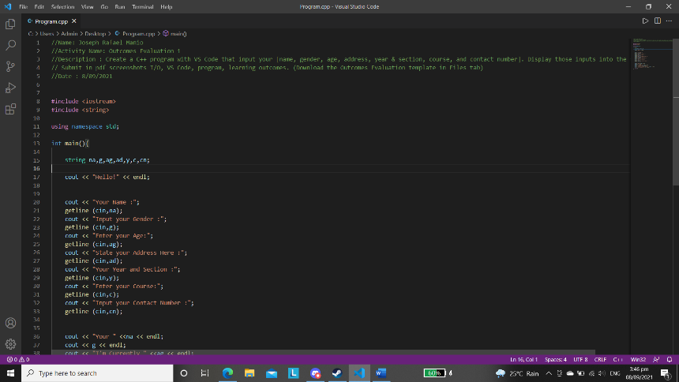

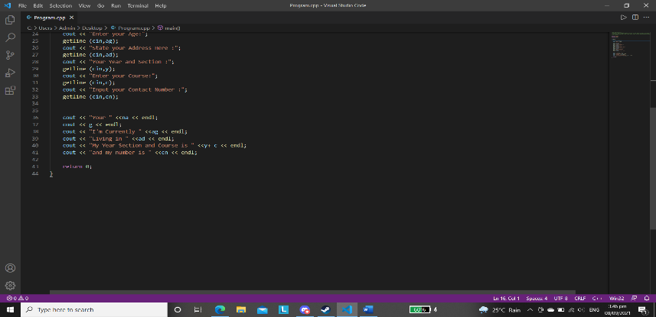

1. **Sample Input/Output**

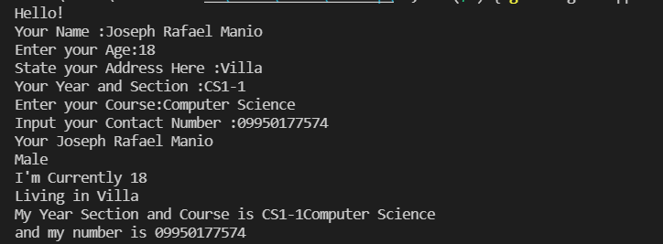

1. **PROGRAM SOURCE CODE**
2. #include <iostream>
3. #include <string>
4. using namespace std;
5. int main(){
6. string na,g,ag,ad,y,c,cn;
7. cout << "Hello!" << endl;
8. cout << "Your Name :";
9. getline (cin,na);
10. cout << "Input your Gender :";
11. getline (cin,g);
12. cout << "Enter your Age:";
13. getline (cin,ag);
14. cout << "State your Address Here :";
15. getline (cin,ad);
16. cout << "Your Year and Section :";
17. getline (cin,y);
18. cout << "Enter your Course:";
19. getline (cin,c);
20. cout << "Input your Contact Number :";
21. getline (cin,cn);
22. cout << "Your " <<na << endl;
23. cout << g << endl;
24. cout << "I'm Currently " <<ag << endl;
25. cout << "Living in " <<ad << endl;
26. cout << "My Year Section and Course is " <<y+ c << endl;
27. cout << "and my number is " <<cn << endl;
29. return 0;
30. }
31. **LEARNING OUTCOME**

**I learned a lot while trying to find answers on my code especially the last part where I need to browse google how can I break the words because it is clumping all together when I first tried it. Turns out that after many trials and error, the answer was just in the semi colon. I had a lot of things to learn to and expect more in this subject.**

1. **REFERENCES (If any…)**